YOUR FEAR INTELLIGENCE WORKSHOP COMPANION
Transform Today's Insights into Lasting Leadership Change

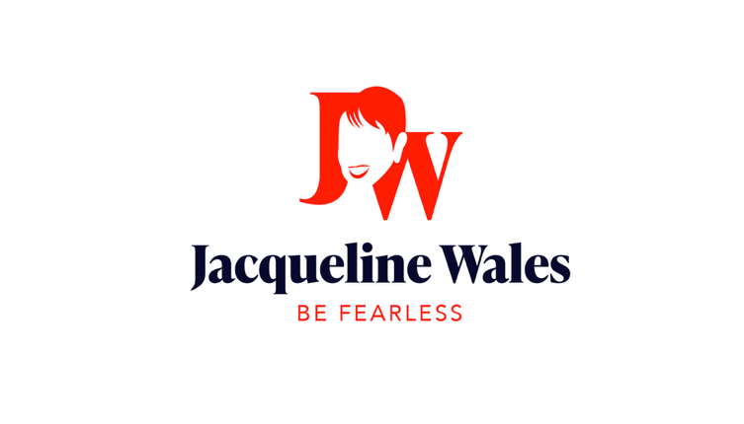

WELCOME TO YOUR TRANSFORMATION JOURNEY
Thanks for showing up today with your courage and authenticity. What you experienced in today's workshop—the insights, the discomfort, the breakthrough moments—that's just the starting line of your fear intelligence transformation.
This companion guide will help you:

- Lock in the key concepts from today's presentation Practice the tools we explored together
- Navigate the resistance that's coming (because it always does)
- Access resources for deeper transformation

Most importantly, it's designed to prevent the #1 workshop trap: the inspiration fade. You know what I'm talking about—that slow drift back to old patterns because change is hard without support.
We're not letting that happen to you.

The F.U.E.L Framework: Fear Intelligence for Transformational Leadership

F - FEEL the Fear
Acknowledge fear without judgment. Recognize physical sensations and emotional signals. → Name it to tame it

U - UNDERSTAND Your Stories
Examine the narrative driving your response. Question beliefs and distinguish facts from fear. → Challenge the narrative

E - EXPLORE with Curiosity
Ask powerful questions. Discover what this fear reveals about values and growth opportunities. → Transform threat into possibility and opportunity

L - LEAD with Courage
Act. Guide yourself and others through uncertainty with purpose. → Feel the fear but don’t let it stop you as you take each step toward your goals

Transform fear from limitation into fuel through conscious awareness and courageous action
A continuous practice that builds fear intelligence and leadership resilience

CAPTURING YOUR WORKSHOP INSIGHTS

Which of the four professional fear types resonated most with you?

- Inadequacy Fear - "I'm not good enough"

- Rejection Fear - "They won't accept me"

- Uncertainty Fear - "I need to know how this ends"

- Loss Fear - "I might lose what I have"

What fear-based behavior pattern did you recognize in yourself during the "What Do YOU Fear?" exercise?

What story have you been telling yourself that you're now ready to question?

Key Insights from Today's Presentation
The biggest "aha" moment for you when we talked about being FEAR- INTELLIGENT vs. FEAR- LESS:

From the "Be-Do-Have" transformation model, what's one behavior you're ready to change?

When we discussed how fear impacts your employees, what pattern did you recognize in your own leadership?

THE 5-DAY FEAR INTELLIGENCE IMPLEMENTATION

For the next 5-days consider what you have learned today and take time to reflect to enhance the learning and develop your fear intelligence

Day 1: The Fear Check-In Practice
Your Challenge: If you are feeling nervous before an important interaction, pause and ask: "What am I afraid might happen here?"

My observations:

Day 2: The "Be-Do-Have" Shift

Your Challenge:

Pick one fear-based behavior from your current state and practice the future state version. Download the Be-Do-Have Model from https://jacquelinewales.com/vistage/
Current Fear Based behavior:

New behavior to practice:

Future behavior result:

What difference will this make in your life?

Day 3: The Employee Impact Reality Check

Frequently we don’t notice what is going on with our employees because we simply want the job done. Giving some thought to the signals of toxic work engagement and taking steps to remedy them is the key to a successful business.
Your Challenge: Observe your team for signs of the fear-based impacts we discussed (micromanagement, poor communication, blame, etc.).
What I observed:

Cost to the team:

One change I'll make:

Day 5: The Psychological Safety Test
Your Challenge: Ask your team "What's not working?" and listen without defending.

What they shared:

My initial reaction:

What I learned:

When Resistance Shows Up (And it will)

The Motivation Dip
Remember: transformation isn't linear. You'll have days when you feel inspired and days when you want to revert to old patterns. This is normal, not failure.
When motivation dips, try this:

The 2-Minute Rule: STOP – LISTEN – BREATHE – Use the F.U.E.L Framework. Do it immediately before your brain creates resistance.
Review: Reread this guide and your notes from today's session. Remind yourself what you discovered.
Reach out To An Accountability Partner: Connect with someone from today's workshop. Check in on each other's progress. Small steps are accumulation of bigger steps.

When Your Team Pushes Back
As you become more fear-intelligent and authentic, some people might resist the "new you." They were comfortable with your old patterns.
Remember from today's discussion:

- You can't control others' reactions
- Their discomfort with your growth says more about them than you
- Not everyone will celebrate your transformation (and that's okay)
- The right people will respect your authenticity

Response Strategies:

- Stay centered in your values
- Don't over-explain or justify your changes
- Give people time to adjust to the new you
- Surround yourself with supporters

Your 30-Day Implementation Plan
Based on today's workshop make a commitment to:

  - Complete the 5-day implementation challenge in this guide
  - Take the complete Fear Intelligence Assessment
  - Implement one psychological safety practice with my team
  - Use the Be-Do-Have model on one speciﬁc behavior
  - Ask for support when I need it
  - Celebrate small wins along the way

Resources for Continued Growth

Essential Reading
Core Resource:
"Unleash the Power of Fear" by Jacqueline Wales (the complete methodology)
Available October 2025.

Complementary Reading:
"The Fearless Organization" by Amy Edmondson
"Dare to Lead" by Brené Brown
"Think Again" by Adam Grant

Complimentary Resources:
- Complete Fear Intelligence Assessment: https://jacquelnewales.com
- 30-day Fear as Fuel Challenge https://jacquelinewales.com/fearasfuel/

Would you like to work with Jacqueline?

Individual Coaching
1-on-1 Executive Coaching focused on:
- Deep fear pattern transformation using the four types framework
- Leadership presence and authenticity
- Difﬁcult conversation mastery
- Organizational change leadership

Typical client results in 6 months:

- 67% increase in leadership conﬁdence
- 45% improvement in team engagement
- 23% faster decision-making
- Signiﬁcant career advancement

Team and Organizational Consulting

Working with teams who are eager to grow is a company’s superpower. Giving people the resources to do that is the key to better performance, retention and growth of the company.
Transform your entire leadership team:

- Fear Intelligence Leadership Assessment
- Individual and Team Leadership Behavioral Assessments (LSI)
- Senior Leadership and Manager training in fear-intelligent leadership
- Individual coaching sessions
- Group transformation planning using Be-Do-Have model
- 6-month implementation support

Schedule a complimentary session with Jacqueline to discuss your needs

Immediate Next Steps

Before you leave today:

Schedule your ﬁrst fear intelligence consultation with Jacqueline
Set a calendar reminder to review this guide in one week
Decide which resource you'll access ﬁrst

Within 48 hours:

Take the complete Fear Intelligence Assessment
Share one insight from today with someone important to you
Begin the 5-day implementation challenge

Within 30 days:

Complete the challenge and review your growth Decide if you want individual or team support
Schedule a follow-up conversation with Jacqueline
Plan how you'll bring fear intelligence to your organization

Contact Information:

- Email: jacqueline@jacquelinewales.com
- Website: jacquelinewales.com
- LinkedIn: https://linkedin.com/in/jacquelinewales
- Vistage Resources: jacquelinewales.com/vistage

Thank you for your courage today. I can't wait to hear about your transformation.

With excitement for your journey,

Jacqueline Wales

© 2025 Jacqueline Wales. This workshop companion is exclusively for attendees of Fear Intelligence workshops.

Closing Thoughts
Today you took a courageous step by exploring your relationship with fear. That courage is what will fuel your transformation.
Remember the key insights from today:

- Fear is imagination-based—the stories we tell ourselves
- Don't be fear-less, be fear-intelligent
- Fear is a reaction, courage is a decision
- The four types of professional fear all have gifts when properly channeled
- Your only limit is your mind

Your fear intelligence transformation doesn't end when you leave today's workshop. It begins.
What's your next courageous move?

